Reciprocal Pronouns

🔹 What Are Reciprocal Pronouns?
# Source: AI Source: Provided by: [Data Path: Persons Table -> ID Column: 1, Name_En Column: Motasem Essam] -> From: [Chatgpt (GPT-4-turbo)] on [7/27/2025]
Reciprocal pronouns are used when two or more people are doing the same thing to each other — the action is shared or mutual.

✅ There Are Only Two Reciprocal Pronouns:
# Source: AI Source: Provided by: [Data Path: Persons Table -> ID Column: 1, Name_En Column: Motasem Essam] -> From: [Chatgpt (GPT-4-turbo)] on [7/27/2025]
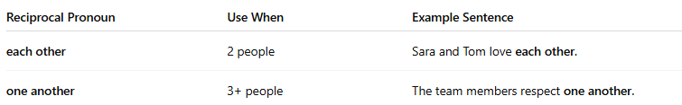
Reciprocal Pronoun | Use When | Example Sentence
each other | 2 people | Sara and Tom love each other.
one another | 3+ people | The team members respect one another.

📚 Examples in Sentences
# Source: AI Source: Provided by: [Data Path: Persons Table -> ID Column: 1, Name_En Column: Motasem Essam] -> From: [Chatgpt (GPT-4-turbo)] on [7/27/2025]
- The students helped each other with homework.
- The guests greeted one another politely.
- We should treat each other with kindness.
- The dogs were biting each other!

🧠 Notes:
# Source: AI Source: Provided by: [Data Path: Persons Table -> ID Column: 1, Name_En Column: Motasem Essam] -> From: [Chatgpt (GPT-4-turbo)] on [7/27/2025]
- Each other is usually used for two people or things.
- One another is more common when talking about three or more, but today many people use them interchangeably in everyday English.

✅ Summary Table
# Source: AI Source: Provided by: [Data Path: Persons Table -> ID Column: 1, Name_En Column: Motasem Essam] -> From: [Chatgpt (GPT-4-turbo)] on [7/27/2025]

Action Type | Example
One-way | She hugged him.
Two-way (mutual) | They hugged each other.

